Riphah International University
Gulberg Green Campus Islamabad
Faculty of Computing (WISH)



Name: Anisha Rehmat.
Sap ID: 78019.
Submitted To: Mam Nayab Khalid
Submitted by: Anisha Rehmat.

Supervision and Coordination

Miss Shazwa Tun Naeem
Lecturer
Faculty of Computing

Lab Designers

Miss Nayab Khalid
Teaching Fellow
Faculty of Computing

Lab Task 1

Learning Outcomes
· Explain variables and common C++ data types.
· Use sequence, selection, and repetition in programs.
· Create and call functions and explain pass by value/reference.
· Create and process arrays using indexes and loops.
· Create structures and access their members.

Lab Tasks

Task 1: — Calculate Average

Create a function float calculateAverage(int arr[], int size) that receives an integer array and its size and returns the average of its elements. In main(), ask the user for the number of elements, validate that it is positive, input the elements, call the function, and display the average.

Code:

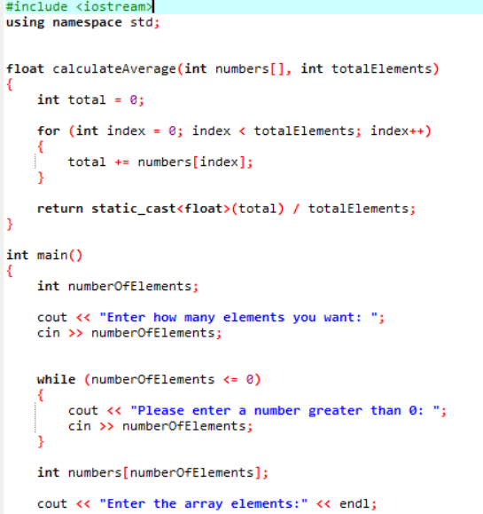

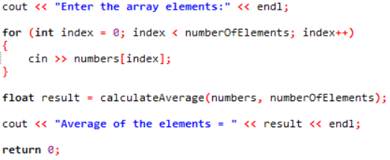

Output:

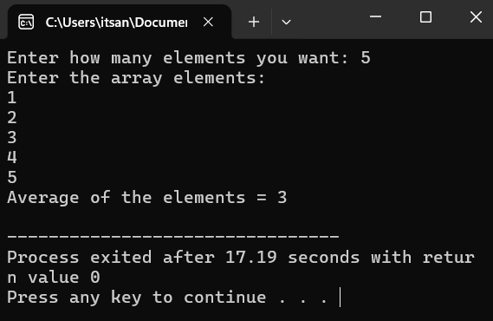

Task 2 — Student Records

Define a Student struct with string name, int rollNumber, and float marks. Create an array of three Student structs, input the information for each student, and display all records.

Code:-
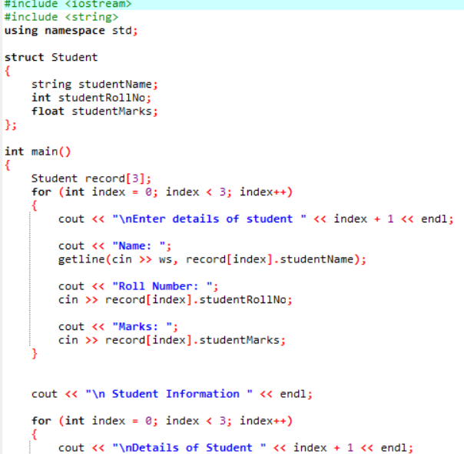

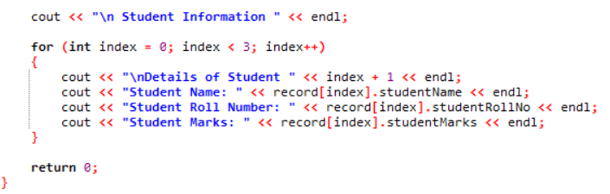

Output:-
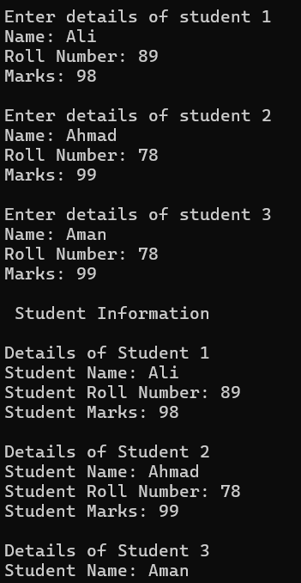

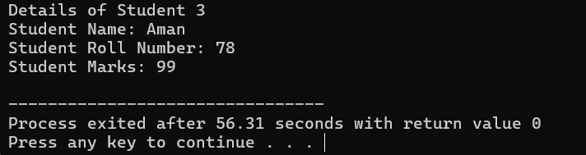

Task 3 __ Check Number
Write a C++ program that asks the user to enter a number and checks whether the number is positive, negative, or zero. Use appropriate conditional statements to make the decision and display the result.
Code:-

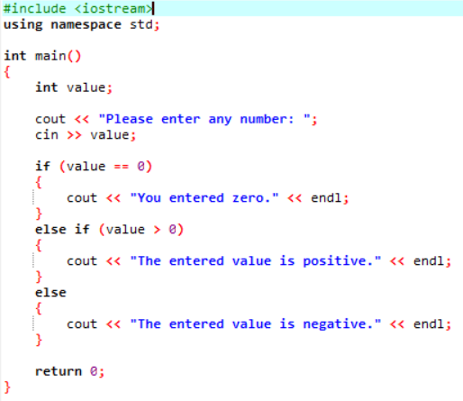

Output:-

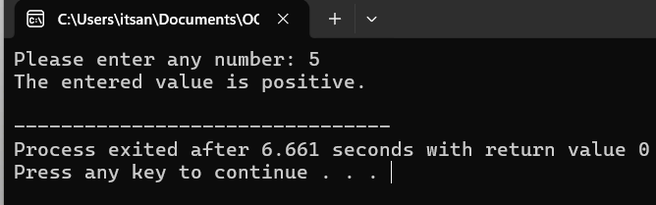

Task 4 __ Find Maximum

Write a C++ program that stores five integers in an array and creates a function int findMaximum(int arr[], int size) to find and return the largest element in the array. In main(), input the elements, call the function, and display the largest number.

Code:-
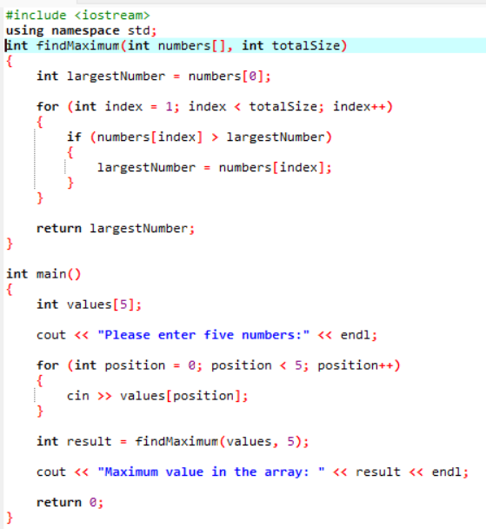

Output:-


